PUBLIC NOTICE
Call for interest to identify public authorities interested in joining the preparation of a pre-commercial public procurement aimed to find innovative and cost-effective solutions for brownfields decontamination.
Publishing date: July 2015
Deadline: December 2015

Objective
The Call for Interest is addressed at public procurers, soil owners and management authorities involved in the procurement chain interested in investigating in practice new approaches to procure innovation in the area of brownfield decontamination and potentially interested to join the preparation of a pre-commercial public procurement (PCP) aimed to find innovative and cost-effective solutions for brownfields decontamination. The overall aim of the call to join up actors around common and specific challenges is closely linked to the BRODISE project’s main objective to take advantage of public procurement power to accelerate innovation in the decontamination sector.

Background
“BRODISE - BROWNFIELD Decontamination In Southern Europe” project, funded by Horizon 2020 Programme, has the main objective to mobilise the procurement power of public actors in order to speed up innovation and contribute to solving soil decontamination-related challenges, thus also improving the EU competitiveness in a global market.
The BRODISE consortium is composed of a group of innovation procurement and technical experts and representatives from three pilots: Bilbao (Spain), Trieste (Italy) and Seixal (Portugal).
By facilitating transnational networking around specific technological needs, BRODISE offer an opportunity to partners and interested procurers across EU to re-think and re-design their concrete investments and proceedings for the local brownfields decontamination and remediation plans for the coming years, leveraging their complementarity and creating a critical mass to acquire, during next years, new fit-for-purpose and cost effective innovations.
For more information on the project see: www.brodise.eu
Brownfield sites typically refers to abandoned or underused industrial and commercial properties—such as old process plants, mining sites, and landfills—that are available but contain low levels of environmental contaminants that may complicate reuse or redevelopment of the land. Such sites represent a major environmental challenge, especially in developed countries that have seen the closing or abandonment of many industrial facilities in the past several decades.
The decontamination demand is very fragmented and the value of the procurement is often too modest for the technology providers to ensure an adequate return of the investment, preventing existing resourced to flow to new technological frontiers.
For this reason, BRODISE project wants to mobilize public and private purchasers and networks of cities in the field of soil decontamination, which are sharing the same technological needs as described in Annex II.

Target
The Call for interest is addressed to public and private soil owners and procuring entities responsible for decontamination initiatives in EU Member States and interested to start or plan a joint pre-commercial public procurement process in 2016.

Type of information to be provided
The call for interest requires to public authorities affected by serious case of brownfield contamination to describe the site to be decontaminated, based on technological assessment already carried out, in order to identify common characteristics with the three pilots (Bilbao, Trieste and Seixal) implemented in the project and to create the critical mass on this specific topic.
In order to collect this information, the public authorities interested are invited to answer to the Questionnaire Annex II.
Previous innovation driven procurement experiences are not required, however, applicants will be asked to:
- Appoint a primary contact person (with a good standard of English)
- Be able to finance their participation to the activities (meetings and events in Italy and/or Bilbao and/or Seixal)
- Allow BRODISE project to disseminate the results of their candidate pilots and of their collaboration in the project.

Deadline: Interested procurers should complete in English the Questionnaire Annex II before the 31th December 2015 and send it by e-mail to the application address provided below:

brodise@bilbao.net and
bbg@grupomas.net, sara.bedin@appaltoprecommerciale.it, and
filippi@cittalia.it

All information will be treated confidentially. The selection of the candidates will be done by a BRODISE pilot selection committee. The criteria against which the pilots will be selected are, amongst others:
- Clarity and relevance to the objectives of BRODISE
- Synergies with the three identified pilots (Bilbao, Trieste, Seixal)
- Possible impacts and improvements in the area of soil decontamination
- Compatibility with the BRODISE project timeline.

- Annex I. Questionnaire to be filled.
- Annex II. Technological Prospect and description of three project pilots.
- Annex III. Pre-commercial public procurement (PCP) description.

Annex I
CALL FOR INTEREST
“BRODISE” QUESTIONARIO

Data di applicazione

Città e Paese

Dati personali
- Nome
- Tipo di ente
- Contatti
e-mail
telefono
indirizzo

Descrizione del suolo contaminato:

Localizzazione geografica:

città

Paese:

coordinate:

Inserire link ad una foto o immagine:

Tipologia del suolo:

Proprietà del suolo:

Pubblica: ________________________

Privata:________________________

Gestione del suolo:

Pubblica: _______________________

Privata:________________________
Caratterizzazione del suolo
- uso del suolo
- elementi inquinanti per caratterizzare i suoli
- a ___
- b____
Atti e provvedimenti relativi al processo di decontaminazione
- allocazione di investimenti per la decontaminazione
- vincoli legali

Inquinamento storico?
Si No

Per cause incidentali?
Si No
Presenza di riporti/ex discariche?
Si No
Breve descrizione fonti di contaminazione (30 righe)
Caratterizzazione ambientale eseguita? Si No
Specificare maglia di indagine e profondità campionamenti
Contaminazione presente:
nell’ insaturo
nel saturo
entrambi
Principali inquinanti suolo:
Organici ___________________
Inorganici _________________
Altro_____________________
Estensione contaminazione:
area _____________________________
profondità ________________________
volume presunto/spessore ____________
Parametri sito specifici (soggiacenza falda, conducibilità idraulica, ecc)
______________________________________________
Disponibile modello idrogeologico
Si No
______________________(commento)
Presenza edifici Si No
Destinazione d’uso:
Industriale
Residenziale
Verde
Misto
Commento ____________________

Interesse a partecipare a BRODISE
si, per avere informazioni circa gli strumenti di procurement PCP e PPI
si, per avere informazione circa lo stato dell'arte della tecnologia
si, per fornire/condividere informazioni circa il fabbisogno di innovazione
si, per partecipare a (potenziali) iniziative congiunte di appalto di innovazione
non in questo momento, ma potenzialmente in futuro
no
altro
L'interesse verte su:
PCP
PPI
entrambi
non applicabile
L'interesse e le similarità vertono specialmente su:
pilota di Bilbao
pilota di Seixal
pilota di Trieste
Vuoi essere contattato?
si
no

Tutte le informazioni saranno trattate in modo confidenziale. La selezione dei candidati sarà effettuata da un comitato di selezione BRODISE pilota. I criteri in base ai quali saranno selezionati i piloti sono, tra gli altri:
a) Chiarezza e pertinenza rispetto agli obiettivi di BRODISE
b) sinergie con i tre piloti identificati (Bilbao, Trieste, Seixal)
c) Possibili effetti e miglioramenti in materia di risanamento del suolo
d) Compatibilità con la timeline del progetto BRODISE.

Annex II

Hydrogeological and soil characterization summary study for each Brownfield.
Date: 7th July 2015

The present text summarizes the information available for each site (Seixal, Trieste and Zorrotzaurre-Bilbao) and concludes outlining sites common characteristics and issues.

  - Seixal
LOCATION: South to Lisbon, a former coastal steel industrial activity area, located on the bank of the Tagus River. At present the site is an industries location area. Disposal of waste originated from steel activities (Siderúrgia Nacional), namely clean facilities waste, park raw materials waste, coal, lime, RCD’s, coke distillation residues (tar sludge, coke fines, etc.) among others.
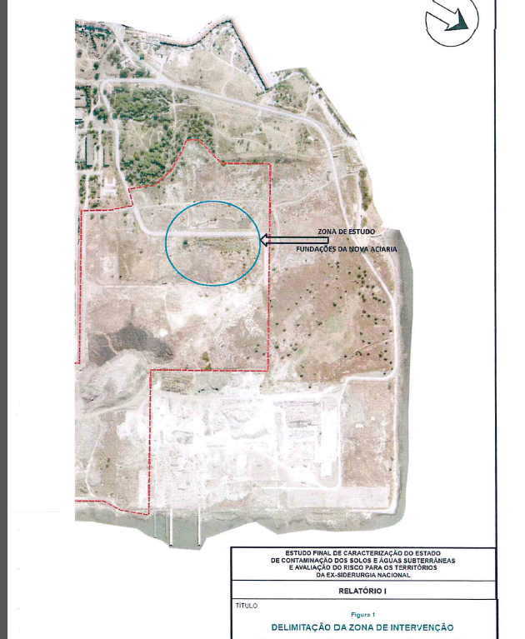
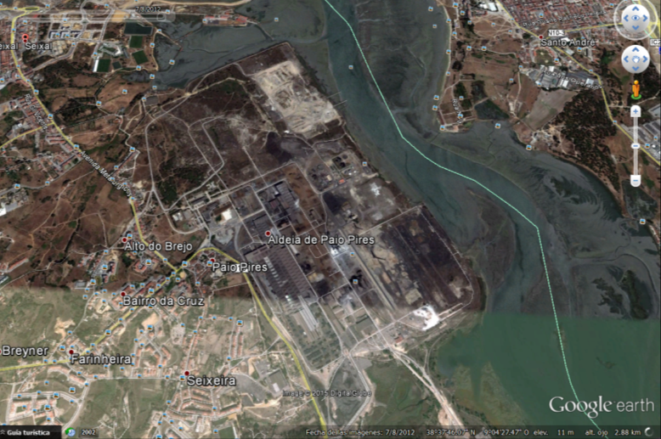
Figure 1. Location of the Seixal Site. In detail, on the right.

AREA OF STUDY: 11.500 m² approx., and detailed investigated area called “Fundaçöes de Nova Aciaria”. There were no industrial activities in this area. This area was originally excavated for the construction of a New Steelworks, but it was never built up, and so, the excavated area forming a pit was filled by industrial waste resulting from steelmaking process. Hazardous and non-hazardous wastes were deposited in this depression randomly. In the surrounding area to this waste disposal there are other scattered waste, mainly consisting of RCDs and mixtures of non-hazardous waste resulting from the steelmaking process.
HISTORICAL EVOLUTION: The steel industry installation in Paio Pires (Seixal) village dates back to the 60s, having been closed in 2001 with the deactivation of Blast Furnace. The former National Steel activity resulted in important environmental liabilities which includes the existing waste in the study area.
CURRENT AND FUTURE USES: Current land use in the surrounding: Industrial; future use: industrial activities and logistics.
GEOLOGY AND GEOGRAPHY: anthropic madeground with heterogeneous gravels/slags and other industrial waste (up to 6m thick), over natural soils composed by interbedded clay and sandy layers. Soil max thickness 10-15m locally.
HYDROGEOLOGY: 2 aquifers and 1 aquitard. Free/higher Aquifer: composed of more recent sedimentary debris and the top of the Pliocene (Layer 1) with a thickness near 90m. Materials over the surface of this aquifer mainly correspond to landfills associated with industrial activity in ZI, in some cases to overcome land to the river. Aquitard: composed by thin layers and detrital clay base of Pliocene / Miocene top (layer 2), with about 70m thick. Captive/bellow Aquifer: composed by the base of the Pliocene and Miocene sandstone layers (layer 3) with a thickness of approximately 90m. Hydraulic conductivity. K= 10⁻⁵ to 10⁻⁶ medium-low, according to fine sand to silts. Tidal effect in the groundwater level is not very significate.
SITE CHARACTERIZATION: Soil, Groundwater and waste characterization, hydrogeology study, risk analysis and preliminary remedial action plan. 450 sampling points:
Soil: Superficial soil sampling (10cm): excess of Pb, Zn and Mo; Sub-superficial soil sampling (<1,5m): Pb in excess; Sub-superficial (>1,5m): PAHs (all 16). In waste disposal level we have only PAHs and TPHs in subsurface soil. In the surrounding area we have Pb, Hg, Mo, zinc, copper, cadmium, antimony, thallium and vanadium.
Main Conclusions→PAHs pollution
Waste characterization: coal, RC&Ds, raw materials, C&Ds, tar wastes, Coque fines, slags, etc. Most remarkable:
Waste type | hazard | Quantity |  | Thickness
Mixing of hydrocarbons and waste (Fundaçöes Nova Aciaria) | Hazardous | 35.000m³ | 56.000 ton | Average 3m  Max 5m
Table 1. Waste characterization.
Some future uses are located in the hazardous waste area (Nova Aciaria). Issue: high waste nature variability-Waste disposal very heterogeneous with not known disposal pattern. Consequence: Very High costs for hazardous waste management. Pollutants of concern: PAHs, long chain TPHs, phenols, fluorides, STD, Hg, Pb, TOC.
Groundwater: no potable gw extraction. Clue compounds: Hg, PAHs, TPHs, BTEX. Organic pollution has a bigger relative relevance than inorganic type pollution. In most of the wells no groundwater pollution was detected.
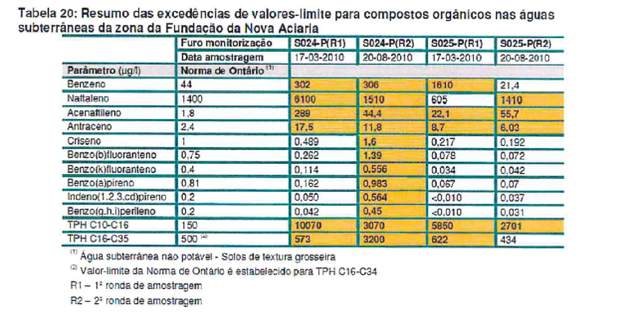
Table 2. Values for Gw over the references for Organic Compounds only.
RISK ANALYSIS: Potential risk in current and future (industrial) scenario, as well as with regard to hypothetical residential use, in case of waste remains. The potential risk is due to high concentration of Naphthalene in the ground and groundwater.
REMEDIAL ACTION PLAN
- WASTE RE-VALORIZATION→Proposal, management as non-hazardous waste landfilling for most of the soils after hydrocarbons separation (energetic re-valorization) /co-incineration of the soils. Other wastes, in especial, furnace “muds” (“lamas de alto forno”), can be recovered by the industry due to its amount of ferric iron. See the Site Area for remediation (Fundações da Nova Aciaria), in Fig. 2.
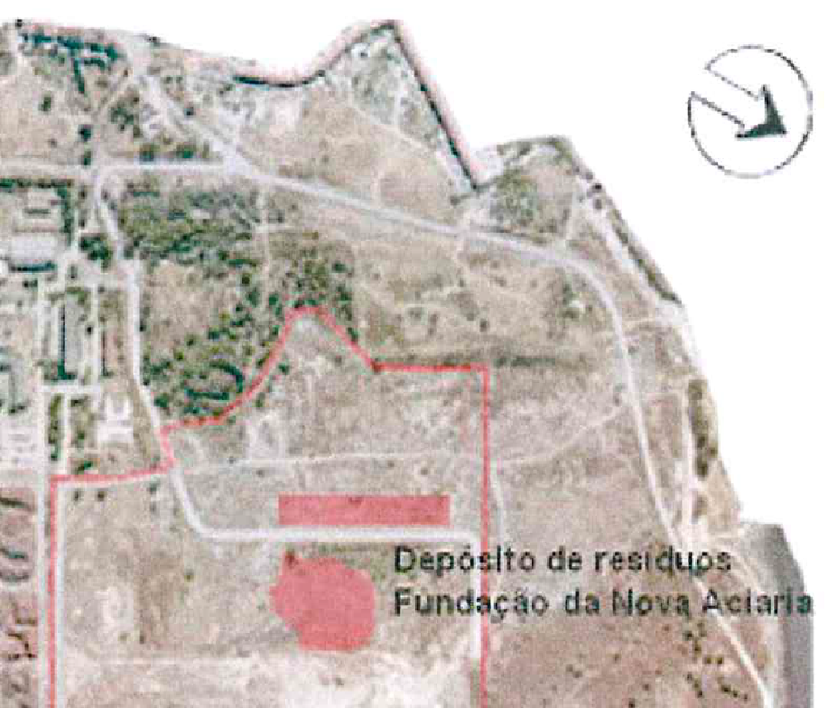
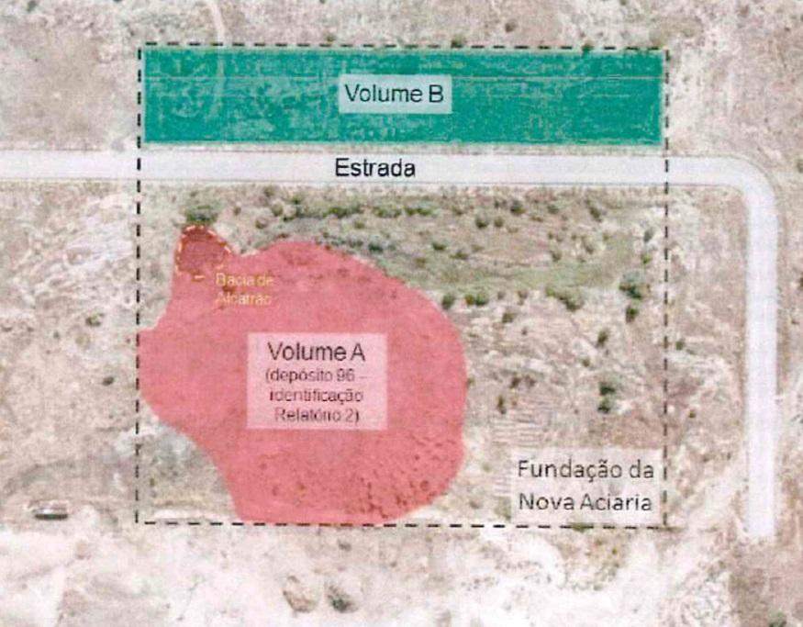
Figure 2. Area to be remediated (fundaçao da Noa Aciaria).

-Tar polluted materials need to be treated mandatory.
- In situ remediation and tar type hydrocarbons seem to be no compatible.
-Thermal desorption initially possible for tars, but no very effective for the existing waste.
-No extraction is possible, due to high tars viscosity, and due to mixing with other compounds (pó de goela).
-Excavation was declared the remediation most suitable option. Total excavation: 83.000m³.

  - Trieste
LOCATION: South to Trieste.
AREA OF STUDY: 1km² aprox. (fig. 3), from which 30ha are EZIT´s property.
HISTORICAL EVOLUTION: Alluvial of Ospo river. In 19th century, crops, and marsh area – Salt production. Industrial activity since 50´s. In 1952, Fornace di Trieste (clay transformation industry) was stablished. Inert and C&D material deposition for site relief modification according to a new activity was performed. After 50´s, filling materials deposition were massive over the full area.
CURRENT AND FUTURE USES: Present→industrial. Future→industrial
GEOLOGY AND GEOGRAPHY: Anthropic materials (waste), from 3 up to 9m thick, over marine fine medium sediments (silts to clays), from 20 to 30m thick, over the rocky flysch type substrate (marls + sands interbedded).
HYDROGEOLOGY: River OSPO channeled for minimizing the flooding risk. New superficial gw aquifer (<3m deep) embedded in the filling layer. 8m max. free aquifer thickness (fig. 4).
Connection of marine water – groundwater in the lower sandy layers. A deeper aquifer exists, but isolated from the superficial one. Very variable hydrogeological characteristics, where permeability coeff.= 10⁻⁸ to 10⁻⁹ cm/s→relatively impermeable sediments (silts and clays with sandy layers interbedded). Gw flux towards Ospo River. Poor or no tidal influence in groundwater levels.
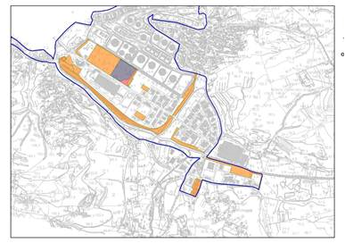
Figure 3. Investigation area in Trieste.
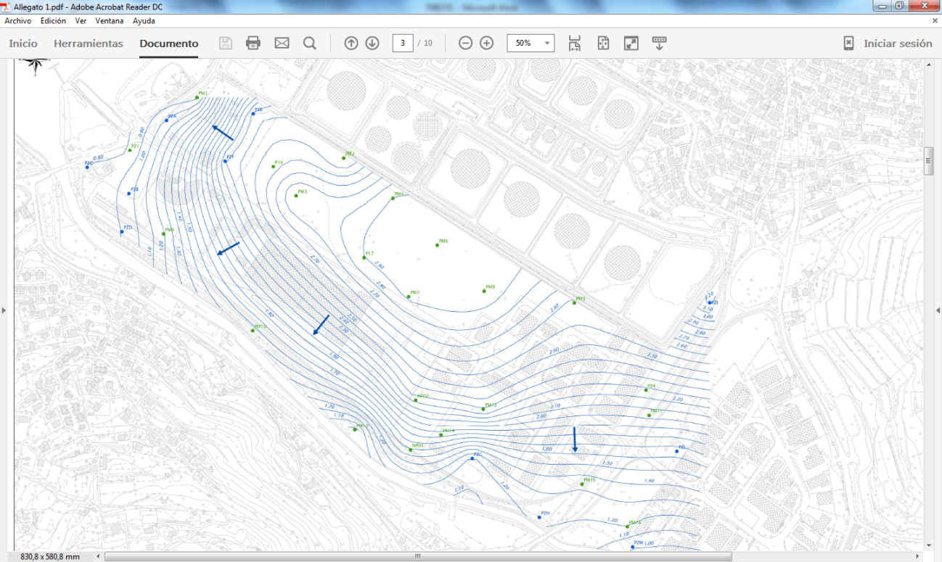
Figure 4. GW flow isolines and hypothetical gw flow direction from a pollution source.

SITE CHARACTERIZATION: 136 drillings, 47 wells, 170 samples top soil= 38 analyzed, 1116 samples analyzed, 27 analysis of fines 17 waste samples = 6 analyzed, 80 gw samples, 5 Lefranc, 5 slug test, 8 multiparametric logs, 3 hydrogeological test, 36 water level measurement. Site characterization and Risk Analysis in elaboration.
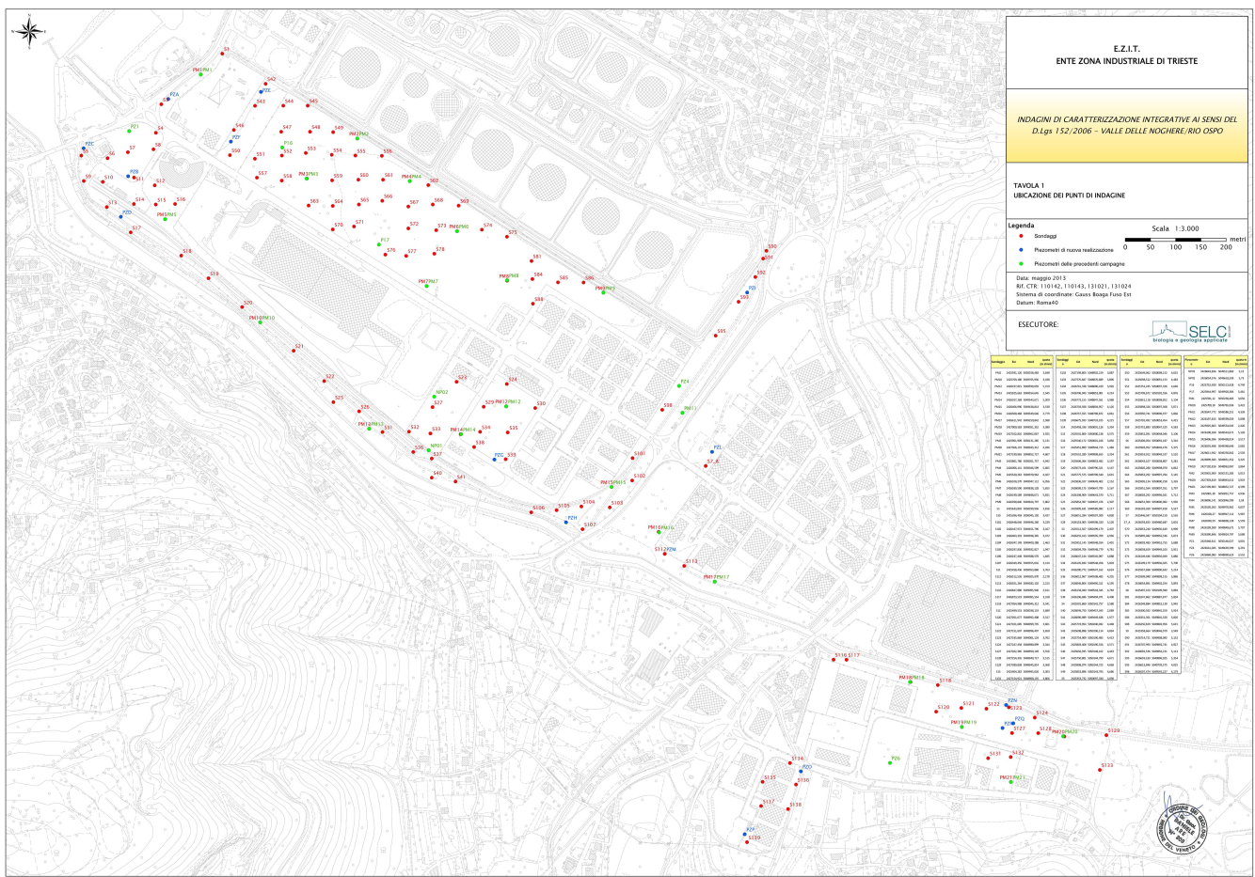
Figure 5. Total sampling points.
Soil: remarkable fact→Hydrocarbons polluted soils.
TPHs: nearly always C>12 hydrocarbons.
HEAVY METALS: As, Cd, Hg, Cu, Zn, Pb as the most remarkable.
PAHs: remarkable appearance of Benzo(a)pyrene, Benzo(ghi)perylene, and Benzanthracene.
Fluorides and/or (PCDD/PCDF = DIOXINES AND FURANOS) in some few points.
GW: Boron, Nitrites, Sulphates, Metals (mainly Fe, Mn and spots of Al, Cr(VI), As, Ni, Se), Trichloroethylene, Tetrachloroetylene, and few points with Benzene, 1,2,3-Tricholopropane and Tricholoromethane
Waste characterization: The madeground material is a mixture of rocky materials + C&D, concrete, hydrocarbons, plastic, crystal, iron, bituminous (tar?).
Groundwater: important elevated conductivity values = salty water
RISK ANALYSIS: in progress.
REMEDIAL ACTION PLAN
Remedial Action Plan proposed for a parcel in EZIT area, for a future industrial use. Excavation as a solution. No economically affordable to manage the soils excavated in this area (40.000m³), since the area does not fulfill the Government standards for being re-used.
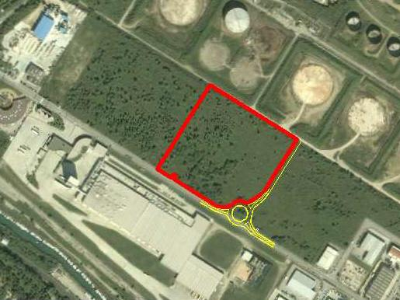
Fig. 6. Area where a new industrial development is projected.
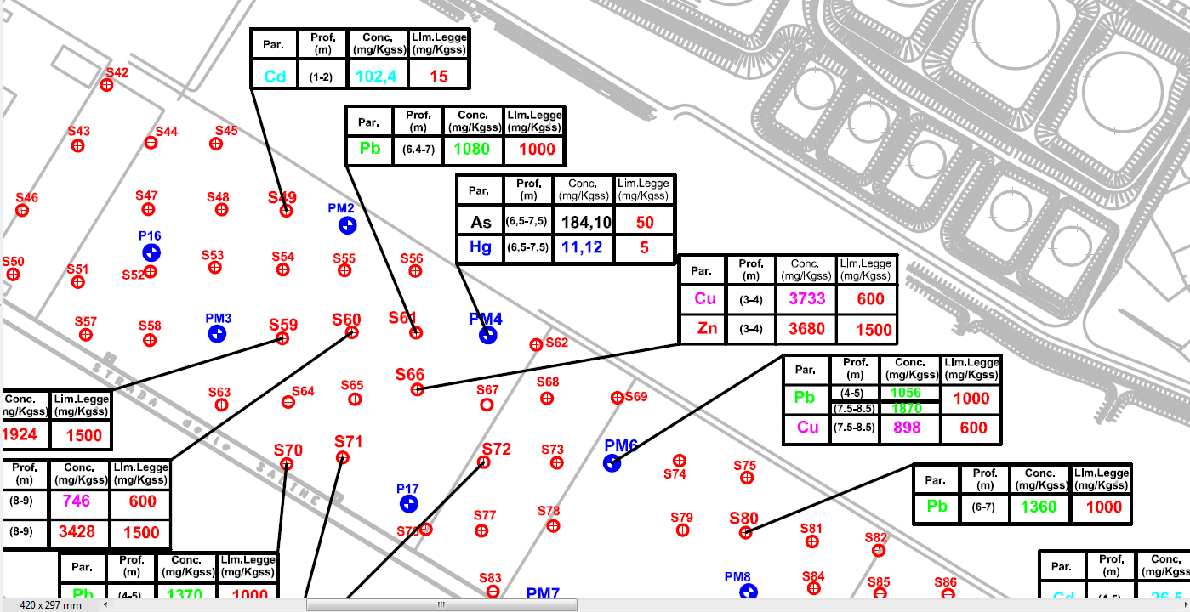
Fig.7. Area shown in figure 4 and soil analytical results for heavy metals.
Waste observed in the parcel to be developed:
-Pyrite toasting Ashes and furnace slags, -silt and gravel and clays, -Sands

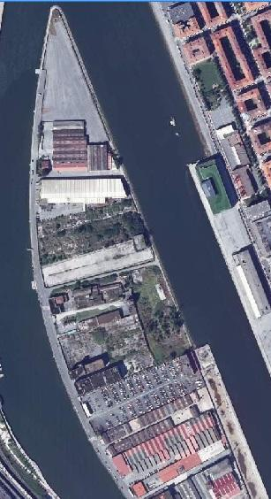
  - Bilbao (Zorrotzaurre)

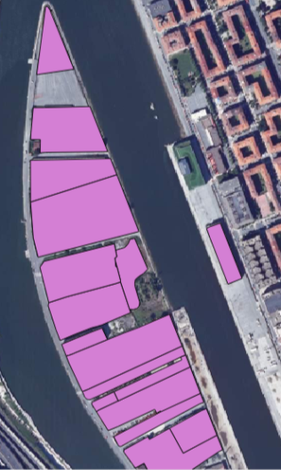
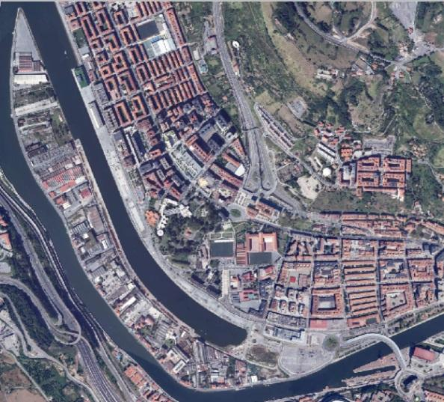
Fig.8 Zorrotzaurre Peninsula (above), and area
where the project will be focused, located
at north of such peninsula. Notice the high
fragmentation of the site (right below).

LOCATION: Northern area of Zorrotzaurre peninsula.
AREA OF STUDY: around 154.000m². Total area of Zorrotzaurre = 834.000m²
HISTORICAL EVOLUTION: historical industrial area, especially intense activity after 50´s of the 20th century. Former inland before construction of a channel in the 60`s. Shipping industry related business, metal and wood processing, metal processing and machine manufacturing, waste process and disposal (furnace pyrite toasting ashes landfill at La Punta), etc.
CURRENT AND FUTURE USES: now industrial (114 companies) and residential (200 homes) uses. A Master Urban Plan is already projected→Future: Total 834.000m², Residential 74% (617.000m²), Bussiness 26% (217.000m²). Houses, offices, industrial buildings, parks, schools, etc.
LAND OWNERSHIP: Public (Bilbao Council and Basque Government) = 51%; Private = 49%. 320 land owners at the moment. Future: 66,8% public, 33,2% private property.
GEOLOGY AND GEOGRAPHY: at top, a concrete or asphalt layer covering a variable anthropic layer of around 2m average thick (gravels, slags, C&D, pyrite ashes in a silt matrix), and 4-6m maximum. Underneath, sedimentary alluvial materials (silts-clays and basal gravels), over flysch origin marls rocky substrate. Sediments can be as thick as 20m.
HYDROGEOLOGY: the peninsula forms a poor free aquifer. Rainfall is infiltrated to the ground, and after a short path is evacuated to the surrounding river Ibaizabal. The tidal influence is not very important (poor tidal effect on the gw level →max of 20cm in some isolated point), but remarkable conductivity (salinity) occasionally. The majority of the top alluvial sediments (silts and clays) show a medium to low permeability (considered as an impermeable base layer), whereas the rocky formation a very low permeability. Poor hydraulic gradients, and flux towards surrounding superficial waters.
SITE CHARACTERIZATION: several soil investigation from historical to detailed and risk analysis. There is a mosaic of reports due to a very fragmented study of the area. Only north area has been intensively investigated.
Soil: heavy metals Pb, As, Cr, Hg, Cd, Mineral oil and PAHs. PCBs occasionally. BTEX as a real issue in one parcel. A general affectation of the top filling materials by metals, TPHs and PAHs. Occasional top natural soil affectation. GW: TPHs, PAHs, BTEX, mainly. Waste characterization: non-hazardous and hazardous. Hazardous: C&D, ashes (from Pyrite transformation process at La Punta) and TPHs+BETX polluted parcel. Groundwater: Heavy metals As and Pb, and TPHs+BTEX mainly, free phase in one parcel. No proof of gw pollutants impact to surrounding superficial fluxes.
RISK ANALYSIS: several risk analysis have been performed for the site. Potential risks for future users have been reported in some areas. Remedial Action Plans proposed.
REMEDIAL ACTION PLAN: an urban plan is already performed for all Zorrotzaurre. It will involve the construction of new infrastructures, soil movement, etc. Remedial Action Plans→due to construction mandatory excavation, and due to risk analysis requirements in some parcels. Remediation Plan for pyrite ashes landfill (La Punta), and a parcel with underground hydrocarbons storage tanks (including gw TPHs pumping). It considers the remediation of some parcels, excavation of big areas for new buildings, and rehabilitation of existing old houses.

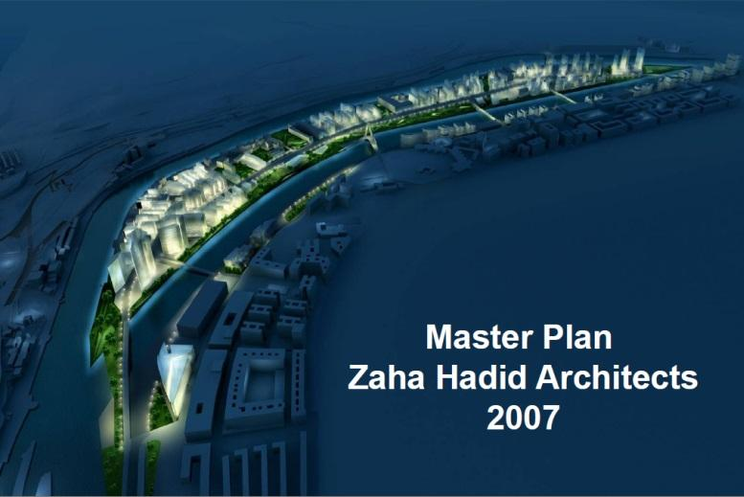
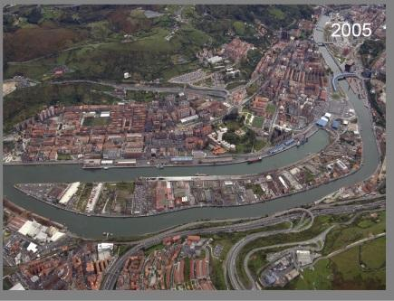
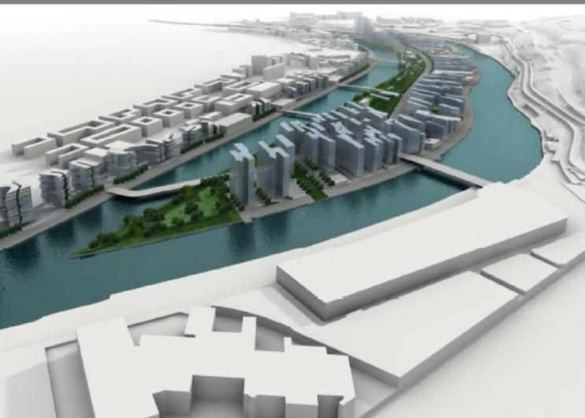
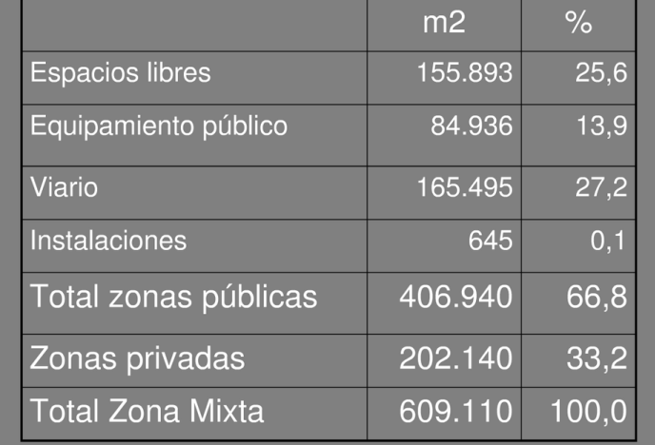
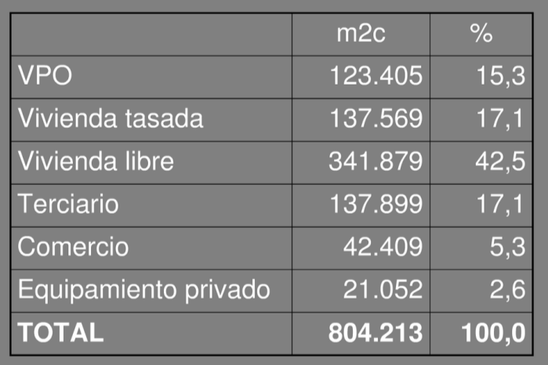

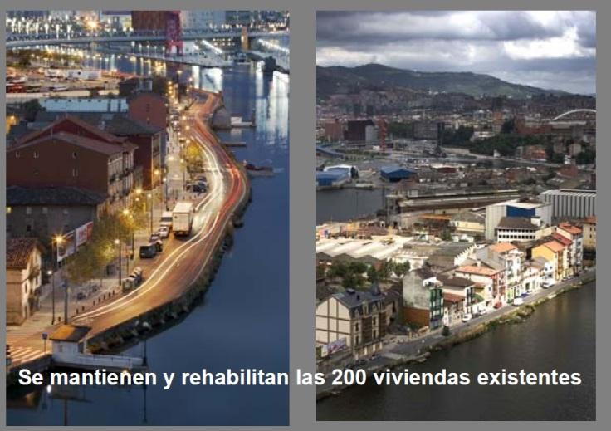
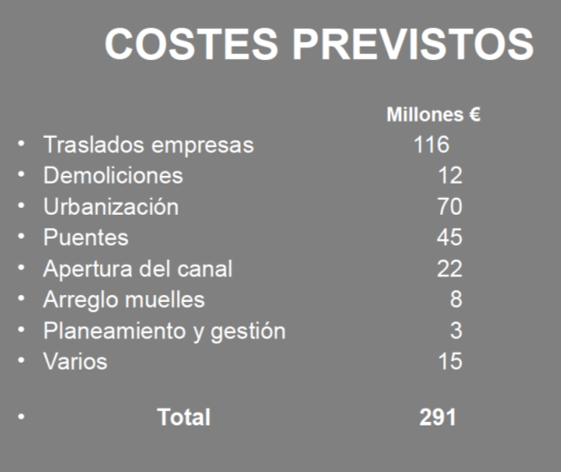
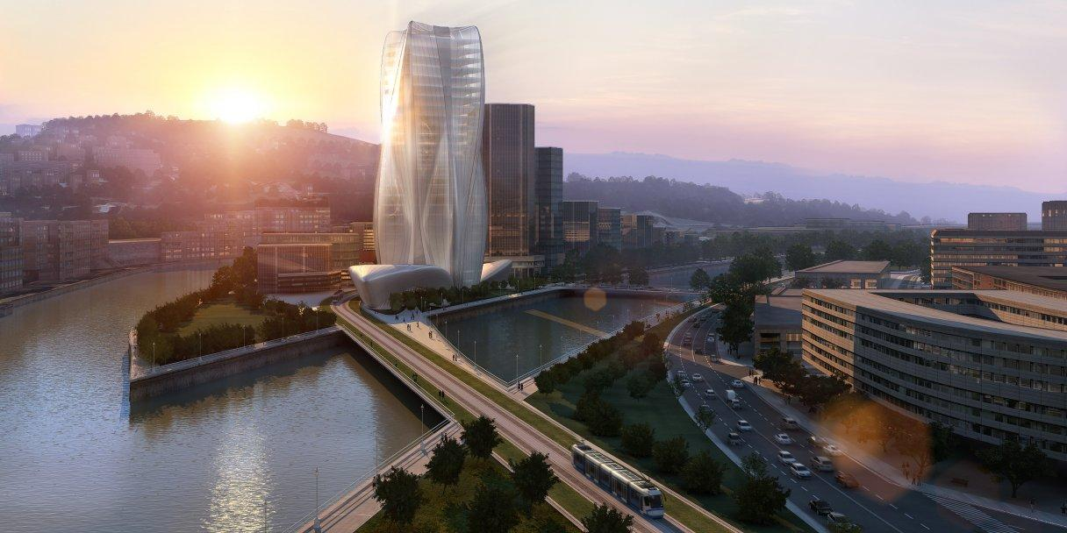
Figure 9. Urban Plan for Zorrozaurre (Bilbao) and future view towards North.

- COMMON CHARACTERISTICS
Common 3 sites elements and characteristics are preliminarily listed below. A comparison matrix chart will be completed during next months with a more detailed and analytic evaluation.
ITEM | OBSERVATIONS
LOCATION | Sites close to big coastal urban areas with good access and facilities.
AREA OF STUDY | Between 700 m to 2km long.  Areas around 1km²
HISTORICAL EVOLUTION | Coastal areas modified by humans for industrial activity by remodeling of the relief. Metal processing (furnace) industry as common main industry.
ACTUAL AND FUTURE USES | Now: industrial in Seixal and Trieste; Mix industrial and residential in Zorrotzaurre-Bilbao.  Future: industrial in Seixal and Trieste; industrial and residential in Bilbao. Urban plan defined for Seixal and Bilbao sites.
POLLUTING ACTIVITIES | Common Main activity: Steel industry (Nova Aceria – Seixal) - metal processing and Clay transformation furnace (Trieste).  Others: tar and fuel storage, wood processing and metal mechanization works, C&D re-valorization plant, etc.
SITE CHARACTERIZATION | Detailed search level in all the sites.
GEOLOGY | Coastal and estuary sediments covered by anthropic made ground materials. Plain areas. Groundwater with salty conditions (high conductivity and alkalinity).
OBSERVED SOIL COLUMN | Covering: concrete, asphalt or soil.  Filling materials: spread in all the sites; human anthropic heterogeneous gravels (slags, ashes, C&D waste-bricks) in a silty to sandy matrix. Between 2 to 4m average thickness.  Natural soils: natural soil composed by silts, clays and basal gravels, up to 10 to 30m, plastic and humid. Sands locally.  Rocky substrate: Marls and sandstones.
HYDROGEOLOGY | Superficial free aquifers (<3m thick), with no connection with deeper aquifers. Permanent gw level embedded the made ground materials and/ or top of natural soils. Medium to low natural soil permeability layers.  Rivers draining the superficial aquifer in both sites.
AFFECTATION TO SOILS | Soil quality alteration caused by the anthropic made ground layers;  Most common Pollutants: Heavy metals (Pb, As, Hg, Cd, Cu), TPHs and PAHs.
AFFECTATION TO GW | Related to anthropic material layer leaching, and locally important due to landfilling activities and underground hydrocarbon deposit leaks. Most common pollutants: Heavy metals (Pb, As, Cd, Fe, Mn, Al, Hg), TPHs and PAHs. Locally BTEX remarkable.
WASTE CHARACTERIZATION | Presence of Hazardous characterized Wastes in both 3 sites. Related to Pyrite toasting ashes (Trieste, Bilbao, Seixal), tar mixed heterogeneous gravels (Seixal), and hydrocarbon storage tanks →free phase in both 3 sites.
ENVIRONMENTAL ISSUE  DEVELOPMENT BOTLLENECK | --High volume of Hazardous wastes and large management costs. Volumes from 15.000 (Bilbao) to 40.000m³ (Trieste) hazardous waste.  --Potential risks for actual and future users in some cases.  --Pollution of gw by Hydrocarbons: free phase in both 3 sites.  --Legal standards compliance for soil re-use in the site is an issue.  --No urgent action is foreseen.
REMEDIAL ACTION PLAN | Because of:  -Urban Construction Plan requires soil excavation in all the cases.  -Action Plan determined by the risk analysis.  -Action due to surpassing legal standards regarding to maximum concentration of pollutants in soil and gw.  Excavation and external management to a landfill is the standard remediation technique initially chosen in both 3 cases.

Annex III

What is Pre‐Commercial Procurement (PCP) and Public Procurement of
Innovation (PPI)?

'Pre‐commercial procurement' (PCP) is the procurement of research and development of new innovative solutions before they are commercially available. PCP means the public procurement of research and development services where the contracting authority or contracting entity does not reserve all the results and benefits of the contract exclusively for itself for use in the conduct of its own affairs, but shares them with the providers under market conditions. The contract, the object of which falls within one or several categories of research and development defined in this framework, must be of limited duration and may include the development of prototypes or limited volumes of first products or services in the form of a test series. The purchase of commercial volumes of products or services must not be an object of the same contract.

‘Public Procurement of Innovation’ (PPI) occurs when public authorities act as a launch customer for innovative goods or services. These are typically not yet available on a large‐scale commercial basis and may include conformance testing.4 PPI can be used when challenges can be addressed by innovative solutions that are nearly or already in small quantity on the market and don't need new R&D.

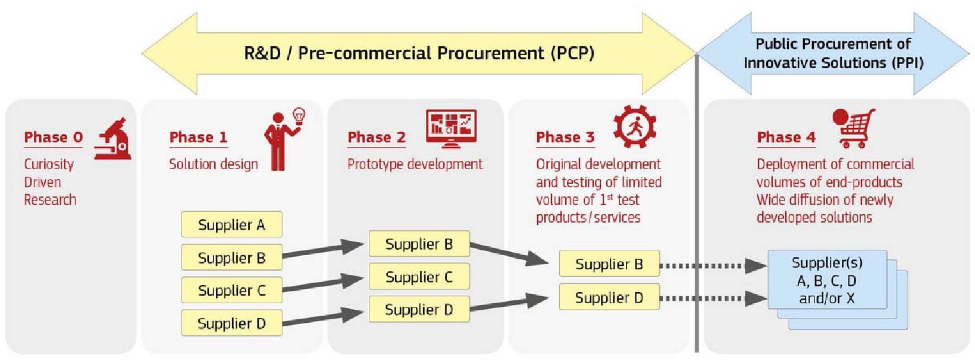

PCP is the procurement of research and development services where the contracting authority or contracting entity does not reserve all the results and benefits of the contract exclusively for itself for use in the conduct of its own affairs, but shares them with the providers under market conditions. Through PCP various operators are appointed at parallel and competitive conditions to develop innovative solutions that are not already available on the market, in order to satisfy the needs and challenges laid down by the public sector. In this sense, pre-commercial procurement is a preparation exercise which enables public purchasers to filter out technological R&D risks of potential alternative solutions before committing to procuring a large scale commercial roll-out.

